1. If 24×38 = *n*×64, then *n* =

(A) 12

(B) 24

(C) 27

(D) 54

(E) 81

2. The lengths of two sides of a triangle are 2 and 9. Which of the following could be the length of the third side?

(A) 4

(B) 6

(C) 8

(D) 12

(E) 14

3. The sale price of a shirt is 40% off its original price of $100. An employee gets an additional 20% off this sale price. What would an employee pay for this shirt if it was purchased on a tax-free day in South Carolina?

(A) $44

(B) $45

(C) $46

(D) $47

(E) $48

4. What is the perimeter of the figure shown, given that there is a right angle at each corner and that two of the sides have lengths 12 and 16 as indicated?

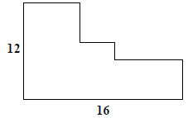

(A) 50

(B) 52

(C) 54

(D) 56

(E) 58

5. Which of the following shapes has the largest area?

(A) A circle with radius of length 3

(B) A square with each side of length 5

(C) A rectangle with sides of lengths 3 and 9

(D) A right triangle with sides of lengths 6, 8, and 10

(E) An equilateral triangle with each side of length 7

6. In which of the following intervals does the number $\sqrt{87654321}$ lie?

(A) [900, 1000]

(B) [9000, 10000]

(C) [90000, 100000]

(D) [2000, 3000]

(E) [20000, 30000]

7. How many different real numbers satisfy the equation below? ${\left(x^{2}+4x-2\right)}^{2}={\left(5x^{2}-1\right)}^{2}$

(A) 0

(B) 1

(C) 2

(D) 3

(E) 4

8. Which of the following numbers has the smallest value?

(A) 1.5

(B)

(C)

(D)

(E)

9. A circle is inscribed in quadrilateral *ABCD* as shown, with *AB* = 16 and *CD* = 10. What is the perimeter of the quadrilateral?

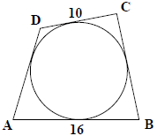

(A) 50

(B) 52

(C) 54

(D) 56

(E) 58

10. Cathy, Bob, and Dave are the members of a science team that has to respond to a true-or-false question. Cathy, Bob, and Dave independently answer the question. Cathy answers the question correctly with probability 80%. Bob also answers the question correctly with probability 80%. Dave is clueless so he answers the question correctly with probability 50%. The team response is the answer chosen by two or more members of the team. What is the probability that the team response is correct?

(A) 60%

(B) 64%

(C) 72%

(D) 75%

(E) 80

11. For each real number *α*, we define $\left\lfloor α\right\rfloor$ to be the greatest integer which is less than or equal to *α*. For example, $\left\lfloor 4.9\right\rfloor$ = 4 and $\left\lfloor 5\right\rfloor$ = 5. If *x* and *y* are real numbers for which $\left\lfloor \sqrt{x}\right\rfloor$ = 9 and $\left\lfloor \sqrt{y}\right\rfloor$ = 12, then the largest possible value of $\left\lfloor x+y\right\rfloor$ is

(A) 225

(B) 242

(C) 256

(D) 268

(E) 270

12. If *a* and *b* are integers for which *a*2-*b*2 = 2003, then what is the value of *a*2+*b*2? Hint: Use the fact that 2003 is a prime number.

(A) 2006005

(B) 2005004

(C) 2004003

(D) 2003002

(E) 2002001

13. Two perpendicular lines, intersecting at the center of a circle of radius 1, divide the circle into four parts. A smaller circle is inscribed in one of those parts as shown. What is the radius of the smaller circle?

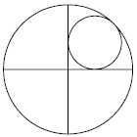

(A)

(B)

(C)

(D)

(E) 2-

14. Let What is the sum of all ten roots of *f*(*x*)?

(A) 55

(B) 99

(C) 100

(D) 110

(E) 120

15. Suppose that *x* and *y* are nonzero numbers for which $xy=\frac{x}{y}=x-y.$ What is the value of *x*+*y*?

(A) -1.5

(B) -0.5

(C) 0

(D) 0.5

(E) 1.5

16. Let *a* and *b* be the two positive solutions to the following equation $\log_{3x}{3}+\log_{27}{3x}=-\frac{4}{3}$. What is the value of *a*+*b*?

(A)

(B)

(C)

(D)

(E)

17. How many solutions does the equation $\cos\left(15θ\right)=\cos\left(3θ\right)$ have with $0°≤θ≤180°$?

(A) 11

(B) 12

(C) 13

(D) 14

(E) 15

18. A circle of area 20 is centered at the point indicated by a solid dot in the accompanying figure. Suppose that $∆$*ABC* is inscribed in that circle and has area 8. The central angles *α*, *β*, and *γ* are as shown. What is the value of ?

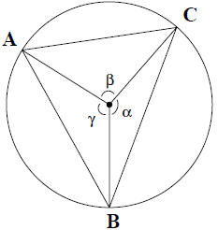

(A)

(B)

(C)

(D)

(E)

19. Let *a*, *b*, and *c* be positive real numbers which satisfy the system of three equations below.

$$\left\{\begin{aligned}a+b^{2}+2ac=29 \\ b+c^{2}+2ab=18 \\ c+a^{2}+2bc=25\end{aligned}\right.$$

What is the value of *a*+*b*+*c*?

(A) 4

(B) 5

(C) 6

(D) 7

(E) 8

20. What is the value of the product below?

(A)

(B)

(C)

(D)

(E)

21. A real-valued function *f* defined for nonzero real numbers satisfies $f\left(\frac{1}{x}\right)+\frac{1}{x}f\left(-x\right)=2x$.

What is the value of *f*(2)?

(A) 2.5

(B) 3

(C) 3.5

(D) 4

(E) 4.5

22. If and , then what is the value of sin2(*A*+*B*)?

(A) 1

(B)

(C)

(D)

(E)

23. Let *x*, *y*, and *z* be positive integers less than 10 such that (100*x*+10*y*+*z*)2 = (*x*+*y*+*z*)5.

(A) 21

(B) 23

(C) 29

(D) 33

(E) 37

24. If *N* is the smallest positive integer such that the remainder when *N* is divided by 5 is 2, the remainder when *N* is divided by 7 is 3, and the remainder when *N* is divided by 9 is 4, then what is the sum of the digits of *N*?

(A) 4

(B) 8

(C) 13

(D) 22

(E) 40

25. For how many integers *n* between 1 and 100, do *n*2+4 and *n*+3 have acommon factor greater than 1?

(A) 0

(B) 3

(C) 5

(D) 7

(E) 11

26. Suppose *AB* and *CD* are two perpendicular chords of the same circle that intersect at the point *E*, *AE* = 12, *DE* = 4 and *CE*= 6. What is the area of the circle?

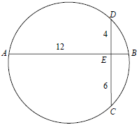

(A) 50 $π$

(B) 45 $π$

(C) 40 $π$

(D) 35

(E) 30

27. For how many positive integers *n*, is 3*n*+81 the square of an integer?

(A) 0

(B) 1

(C) 2

(D) 3

(E) 4

28. The letters *a*, *b*, *c*, *d*, *e*, *f*, *g*, *h* and *i* in the figure below represent thenumbers 1, 2, 3, 4, 5, 6, 7, 8 and 9 in a certain order. In each of the nine circles, we sum the three numbers so that nine sums are obtained. Suppose that all nine sums are equal. What is the value of *a*+*d*+*g*?

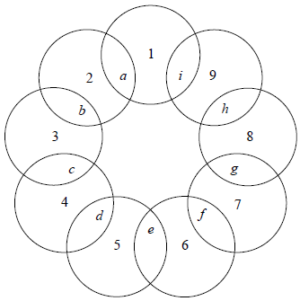

(A) 15

(B) 16

(C) 18

(D) 19

(E) 21

29. What is the smallest positive integer *n* such that 31 divides 5*n*+*n*?

(A) 23

(B) 30

(C) 51

(D) 68

(E) 88

30. The three sides of $∆$*ABC* are extended as shown so that *BD* = 0.5*AB*, *CE* = 0.5*BC*, and *AF* = 0.5*CA*. What is the ratio of the area of $∆$*DEF* to that of $∆$*ABC*?

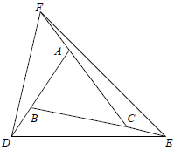

(A) 3:1

(B) 13:4

(C) 7:2

(D) 14:5

(E) 10:3